FOR IMMEDIATE RELEASE
Contact: Holly Goodhart hgoodhart@newonline.org
312.414.0229, ext. 22

Target honored with NEW William J. Grize Award for gender diversity and inclusion
Network of Executive Women award recognizes
strong commitment to advancing all women

AMELIA ISLAND, FLORIDA (January 21, 2019) -- Target Corporation was recognized for its strong commitment to women’s leadership and gender equality in the workplace with the Network of Executive Women’s William J. Grize Award, January 21, 2019 during the Retail Industry Leaders Association’s Retail CEO Forum in Amelia Island, Florida.
The William J. Grize Award is named for the late president and CEO of Stop & Shop, an early champion of gender diversity. Since 2011, the William J. Grize Award has honored industry leaders and companies who have demonstrated "an enduring commitment to the advancement of women and to creating a diverse and inclusive workplace.”
"Target’s leadership team understands that creating a gender diverse and inclusive workplace is a business imperative,” said NEW President and CEO Sarah Alter, who presented the award to Target Chairman and CEO Brian Cornell. “Their efforts to level the playing field and realize the benefits of women’s leadership have served as models for leaders in retail and beyond.”
Target’s commitment to gender equality starts in the C-suite, Alter noted. In 2016, Target signed the White House Equal Pay Pledge, backing up that pledge with a comprehensive annual pay audit and leadership training designed to reduce bias in decision-making.

At HQ and in the field

“But we know real change requires commitment and follow-through at every level,” Alter said. “Target’s gender diversity efforts are strong across functions, as women are represented, heard, recognized and developed as leaders at headquarters and in the field.”
Today almost half of Target’s store managers are female, each overseeing up to 500 employees and responsible for maximizing profitability, guest experience and sales. Women make up 36 percent of Target’s board and 45 percent of its executives.

[more]

[Page 2 -- Target honored with NEW’s William J. Grize Award for gender diversity]

Last year alone, Target was named one of DiversityInc’s Top 50 Companies for Diversity, earned a score of 100 on The Human Rights Campaign’s Corporate Equality Index, was selected as one of the Top Companies for Executive Women by the National Association for Female Executives and was recognized by AnitaB.org as a Top Company for Women Technologists.

“As one of the country’s largest and most successful businesses, Target’s influence on business norms can’t be understated,” Alter said, noting that Cornell has taken a public zero-tolerance stance on sexual harassment and gender bias and has urged male leaders to mentor and sponsor women for leadership roles.
In 2016, Cornell and Indra K. Nooyi, then chairman and CEO of PepsiCo Inc., agreed to co-chair the NEW Future Fund, the Network of Executive Women’s $5 million fundraising initiative. “At the time, [Brian] said, ‘There’s no question we’re making progress, but we still have work to do to achieve gender parity,’” Alter said before presenting the award. “Target continues to be a leader in that work.”

Prior recipients of the William J. Grize Award are:
2011
Linda Dillman, Hewlett-Packard, honored for her work at Walmart Inc.
Jeri Dunn of Bacardi, honored for her work at Tyson Foods
Tom Greco, PepsiCo Inc.
Don Knauss, The Clorox Company
Jeff Noddle, retired CEO of SUPERVALU
Kay Palmer, J.B. Hunt
Judy Spires, Kings Super Markets
James White, Jamba Juice Company, honored for his work at Safeway
Delhaize America
Procter & Gamble
2012
Mike Duke, Walmart Inc.
2013
Regenia Stein, Ingenuity Consulting, honored for her work at Kraft Foods
2014
Mike Gorshe, Accenture
2018
Indra Nooyi, PepsiCo Inc.

ABOUT NEW
Founded in 2001, the Network of Executive Women represents more than 12,000 members, 900 companies, 120 corporate partners and 22 regions in the U.S. and Canada advancing all women and building business. For more information about NEW and its learning programs, events, content and insights, visit newonline.org. Connect with us on social media @newnational.

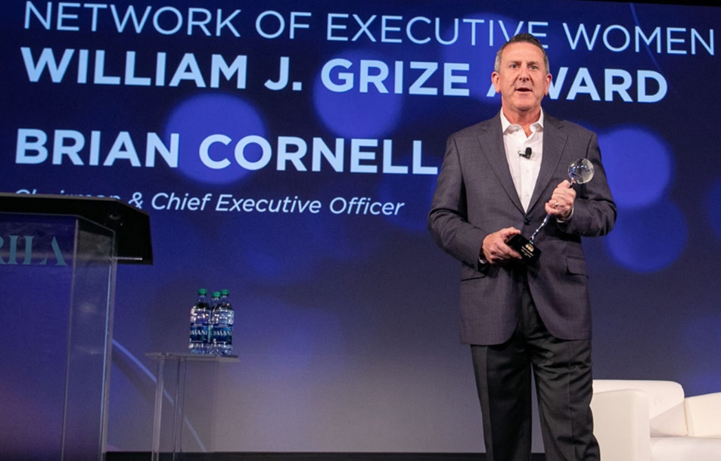
Target Chairman and CEO Brian Cornell accepts the William J. Grize Award for gender diversity and inclusion on behalf of Target. The retailer was recognized for its commitment to women’s leadership and gender equality in the workplace.

Network of Executive Women | 161 N. Clark Street | Chicago, IL 60601

