FOR IMMEDIATE RELEASE
Contact: Holly Goodhart hgoodhart@newonline.org
312.414.0229, ext. 22

Bestselling author Luvvie Ajayi to deliver keynote on speaking truth to power at NEW Summit
Additional keynotes on harnessing the power of one’s experiences will be given by Soraya Chemaly and Lindsey Roy

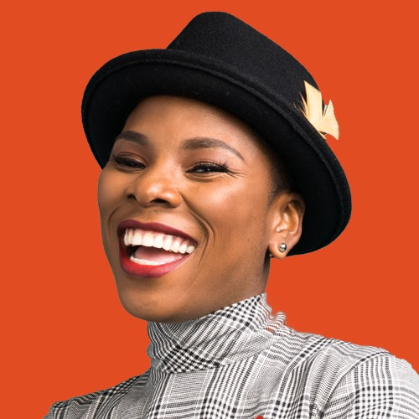
CHICAGO (August 27, 2019)— New York Times bestselling author Luvvie Ajayi will discuss the importance of speaking truth to power on September 23 at Network of Executive Women's 17th annual NEW Leadership Summit. The conference offers NEW members a chance to gather in order to learn, network, and collaborate on the mission of advancing workplace gender equality.
This year’s theme—“By Design: Seeing, Making and Building a NEW Future”—will motivate current and future leaders to look at the state of our workplaces with fresh eyes, to invent new methods for effecting change by championing diversity and inclusion initiatives and to work together to build a world where gender equality is a reality. Summit attendees will gather at the Hyatt Regency Atlanta from September 23–September 25, 2019.
“This will be my third Summit this coming September, and I am as excited for this year’s event as I was for my very first one! There is no greater joy than being in the midst of over 1,300 of our amazing members and leaders for several days,” said Sarah Alter, CEO at NEW.
“We focus this year on the future,” continued Sarah. “A future where all women are advancing in the workplace. Our goal at Summit is to empower and energize you to partner with NEW so that we can all see, make and build that future together.”
An acclaimed writer and speaker; Luvvie Ajayi will discuss the importance of using our collective voices to fight for equality. Other highly anticipated keynotes will come from Soraya Chemaly, activist, media critic and author of Rage Becomes Her: The Power of Women’s Anger; and Lindsey Roy, CMO of Hallmark Greetings.
Press who wish to attend should contact Holly Goodhart, Director of Marketing & Communications, hgoodhart@newonline.org.
ABOUT NEW
Founded in 2001, the Network of Executive Women represents nearly 13,000 members, 900 companies, 120 corporate partners and 22 regions in the U.S. and Canada advancing all women and building business. For more information about NEW and its learning programs, events, content and insights, visit newonline.org. Connect with us on social media @newnational.

