FOR IMMEDIATE RELEASE
Contact: Barb Francella bfrancella@newonline.org
312.414.0229, ext. 21

PepsiCo's Indra Nooyi honored with NEW’s William J. Grize Award
Network of Executive Women award recognizes strong commitment to gender diversity and inclusion

CHICAGO (November 1, 2018) -- PepsiCo Inc. Chairman Indra K. Nooyi was recognized for her career-long commitment to women’s leadership and gender equality with the Network of Executive Women’s William J. Grize Award, Oct. 29, 2018 in Purchase, N.Y.
The William J. Grize Award is named for the late president and CEO of Stop & Shop, an early champion of gender diversity. Since 2011, the William J. Grize Award has honored industry leaders who have demonstrated "an enduring commitment to the advancement of women and to creating a diverse and inclusive workplace.”
"Indra’s contributions to the retail and consumer goods industry cannot be overstated. But, just as great, have been her contributions to gender equality in the workplace,” said NEW President and CEO Sarah Alter, who presented the award with Stop & Shop President Mark McGowan.
“Under Indra’s leadership, PepsiCo has increased the number of women leaders through recruiting and development initiatives,” McGowan said. “Her outspoken advocacy, enduring commitment to gender diversity and inclusion, and status-quo-busting efforts have helped advance women here and around the world.”
Nooyi, who served as CEO of PepsiCo Inc. for 12 years before stepping down Oct. 3, was the chief architect of Performance with Purpose, PepsiCo’s promise to do what’s right for the business by doing what’s right for people and the planet. She serves as co-chair of the NEW Future Fund, a $5 million fund-raising campaign to support NEW’s investments in learning programs, technology, research and insights aimed at achieving
More
Page 2 – Indra Nooyi honored with NEW’s William J. Grize Award
gender equality in retail, consumer goods, financial services and technology.
"Indra’s journey, her achievements and her leadership are inspiring examples of what’s possible,” noted Karen Meleta, vice president of consumer and corporate communications for Wakefern Food Corporation, who facilitated an hour-long discussion and Q&A with Nooyi prior to the award presentation at the NEW New York Metro learning event.
Prior recipients of the William J. Grize Award are:
2011
Linda Dillman, Hewlett-Packard, honored for her work at Walmart Inc.
Jeri Dunn of Bacardi, honored for her work at Tyson Foods
Tom Greco, PepsiCo Inc.
Don Knauss, The Clorox Company
Jeff Noddle, retired CEO of SUPERVALU
Kay Palmer, J.B. Hunt
Judy Spires, Kings Super Markets
James White, Jamba Juice Company, honored for his work at Safeway
2012
Mike Duke, Walmart Inc.
2013
Regenia Stein, Ingenuity Consulting, honored for her work at Kraft Foods
2014
Mike Gorshe, Accenture

ABOUT NEW
Founded in 2001, the Network of Executive Women represents more than 12,000 members, 825 companies, 100 corporate partners and 21 regions in the U.S. and Canada advancing all women and building business. For more information about NEW and its learning programs, events, content and insights, visit newonline.org. Connect with us on social media @NEWnational.

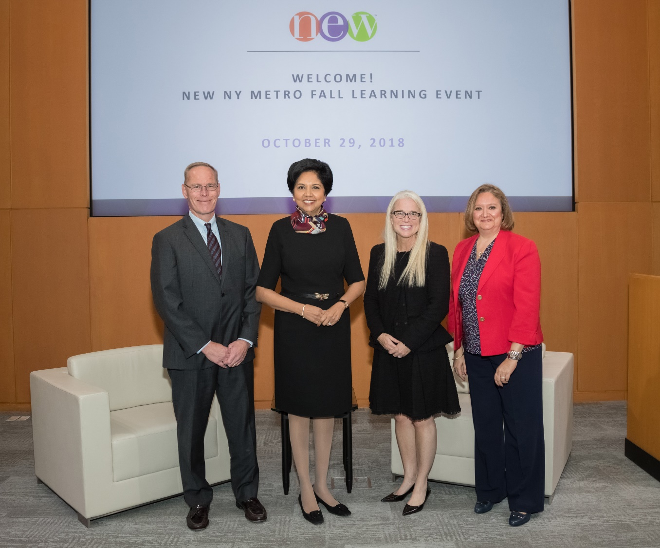
Stop & Shop President Mark McGowan, PepsiCo Inc. Chairman Indra Nooyi, NEW President and CEO Sarah Alter and Wakefern Food Corporation Vice President of Consumer and Corporation Communications Karen Meleta.

Network of Executive Women | 161 N. Clark Street | Chicago, IL 60601

